Q1. First Palindromic String
Aim: To find the first palindromic string in a list.

Code (Python):
words = input("Enter words: ").split() ans = ""
for w in words:
if w == w[::-1]: ans = w break
print("First Palindrome:", ans)

Input:
abc car ada racecar cool

Output:
First Palindrome: ada

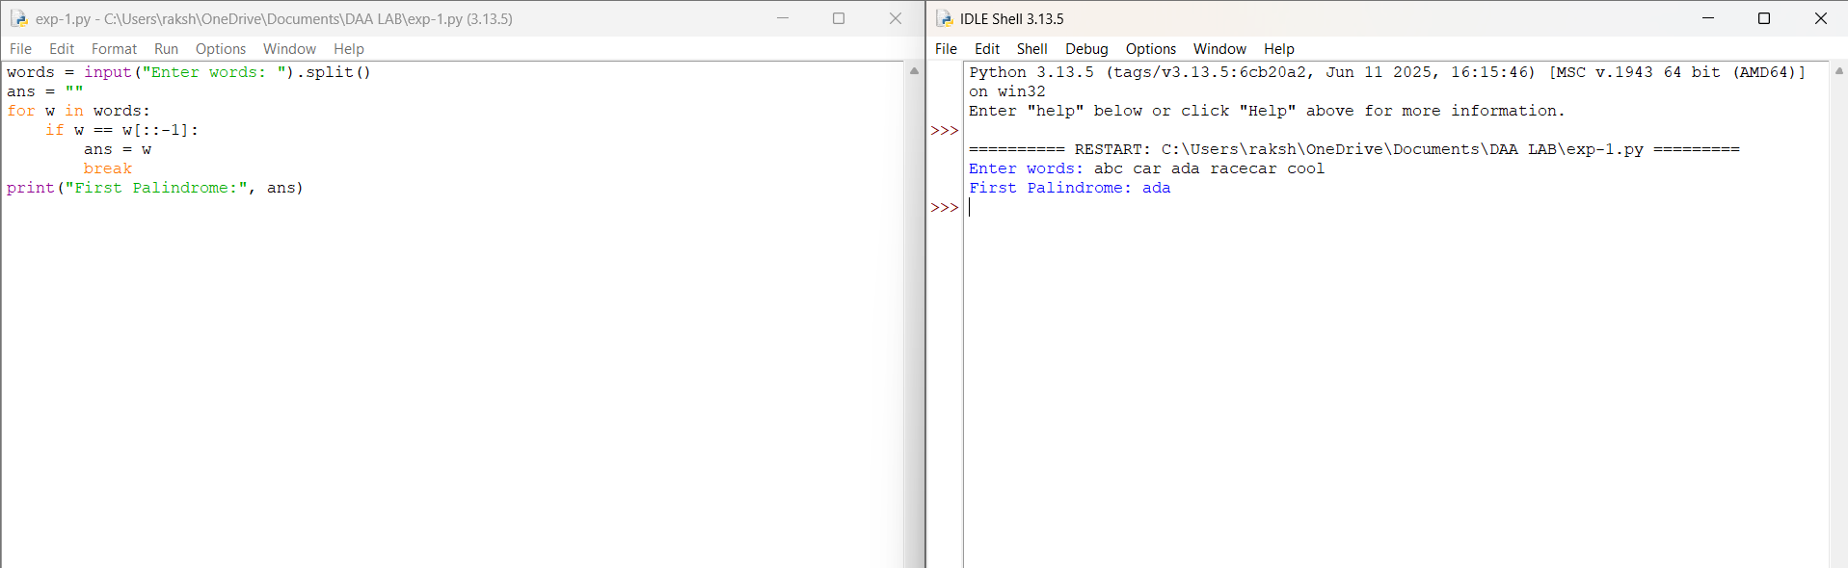

Time Complexity: O(n × m)

Space Complexity: O(m)

Result: The first palindromic string is found successfully.

Q2. Count Common Indices in Two Arrays
Aim: To count how many elements of one list exist in another.

Code (Python):
nums1 = list(map(int, input("Enter nums1: ").split())) nums2 = list(map(int, input("Enter nums2: ").split())) set1, set2 = set(nums1), set(nums2)
answer1 = sum(1 for x in nums1 if x in set2) answer2 = sum(1 for x in nums2 if x in set1) print("Output:", [answer1, answer2])

Input:
Enter nums1: 2 3 2
Enter nums2: 1 2

Output:
[2,1]

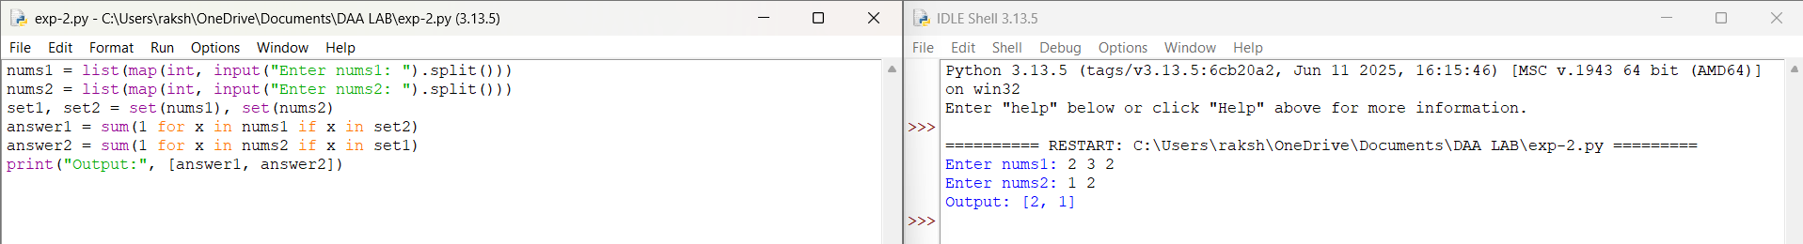

Time Complexity: O(n+m)

Space Complexity: O(n+m)
Result:The number of common elements in both arrays is counted successfully.
Q3. Sum of Squares of Distinct Counts of Subarrays
Aim: To calculate sum of (distinct_count²) for all subarrays.

Code (Python):
nums = list(map(int, input("Enter numbers: ").split())) n = len(nums)
total = 0
for i in range(n): seen = set()
for j in range(i, n): seen.add(nums[j]) total += len(seen) ** 2
print("Sum of squares:", total)

Input:
Enter array: 1 2 1

Output:
Result: 15
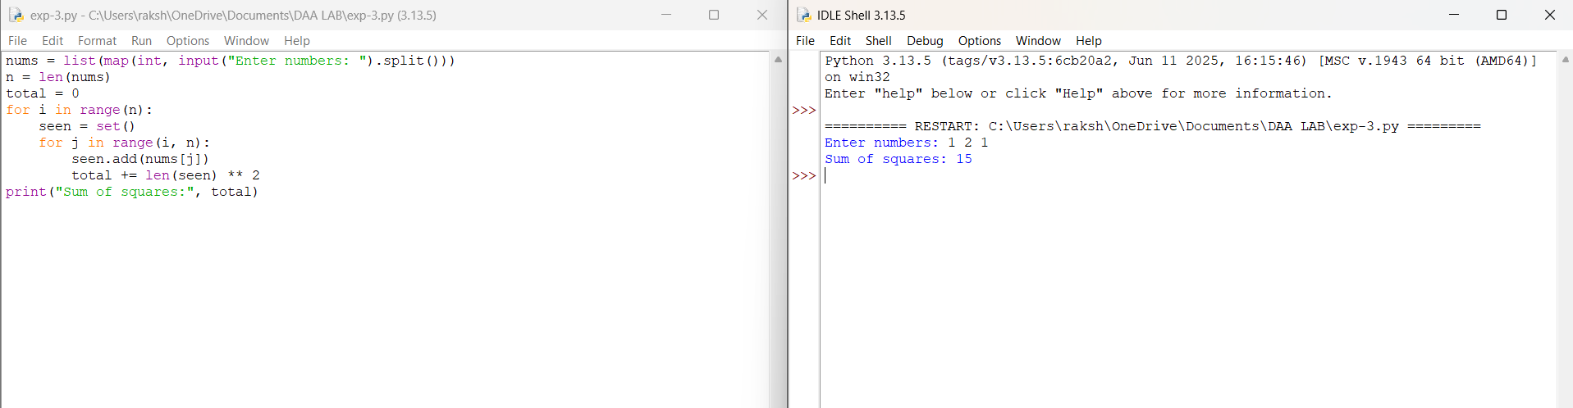

Time Complexity: O(n²)

Space Complexity: O(n)
Result:The sum of squares of distinct counts for all subarrays is calculated successfully.

Q4. Count Pairs with Condition
Aim: To count pairs (i, j) where nums[i] == nums[j] and (i*j) divisible by k.

Code (Python):
nums = list(map(int, input("Enter numbers: ").split())) k = int(input("Enter k: "))
count = 0
n = len(nums) for i in range(n):
for j in range(i+1, n):
if nums[i] == nums[j] and (i*j) % k == 0: count += 1
print("Pairs count:", count)

Input:
Enter nums: 3 1 2 2 2 1 3
Enter k: 2 Output:
Pairs: 4

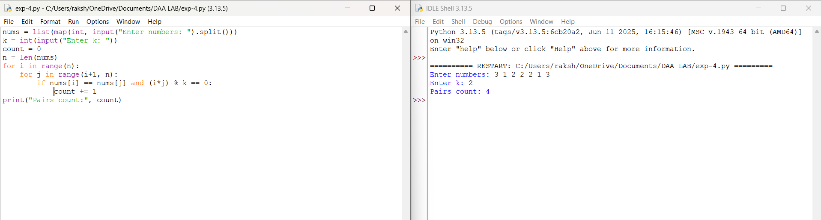

Time Complexity:O(n²)

Space Complexity:O(1)
Result: The number of valid pairs satisfying the given condition is counted successfully.

Q5. Max of Array
Aim: To find maximum element in array with least time complexity.

Code (Python):
arr = list(map(int, input("Enter numbers: ").split())) if not arr:
print("Array is empty") else:
max_val = arr[0] for num in arr:
if num > max_val: max_val = num
print("Maximum:", max_val)

Input:
Enter array: 1 2 3 4 5

Output:
Max: 5

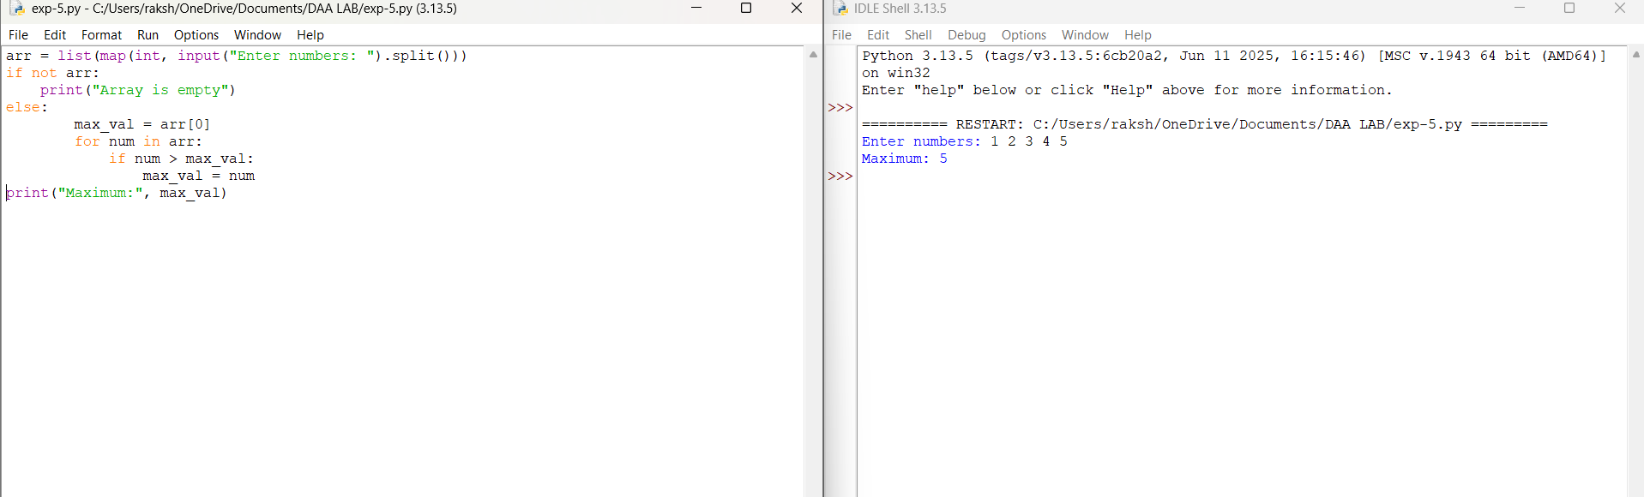

Time Complexity: O(n)

Space Complexity: O(1)
Result: The maximum element is found successfully.

Q6. Sort and Find Maximum
Aim: Sort array and return maximum element.

Python Code:
arr = list(map(int, input("Enter numbers: ").split())) if not arr:
print("Array is empty") else:
arr.sort()
print("Maximum after sorting:", arr[-1])
Input:
Enter numbers:[3, 3, 3, 3, 3]
Output:
Max: 3

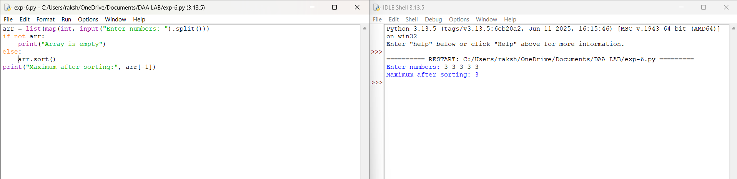

Time Complexity: O(n log n)

Space Complexity: O(1)

Result: The array is sorted and the maximum element is found successfully.

Q7. Unique Elements of List
Aim: Remove duplicates and return only unique elements.

Python Code:
arr = list(map(int, input("Enter numbers: ").split())) unique = list(set(arr))
print("Unique elements:", unique)
Input: 3 7 3 5 2 5 9 2
Output:
Unique: [2, 3, 5, 7, 9]

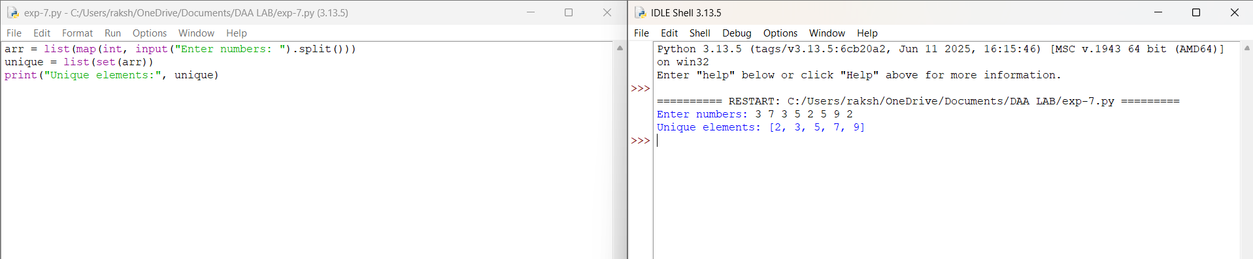

Time Complexity: O(n)

Space Complexity: O(n)

Result: Duplicate elements are removed and unique elements are obtained successfully.
Q8. Bubble Sort

Aim:Sort an array of integers using the Bubble Sort technique.

Python Code:
def bubble_sort(arr): n = len(arr)
for i in range(n): swapped = False
for j in range(0, n-i-1): if arr[j] > arr[j+1]:
arr[j], arr[j+1] = arr[j+1], arr[j] swapped = True
if not swapped: break
return arr
arr = [64, 34, 25, 12, 22, 11, 90]
print("Sorted array:", bubble_sort(arr))

Input: [64, 34, 25, 12, 22, 11, 90]

Output: [11, 12, 22, 25, 34, 64, 90]

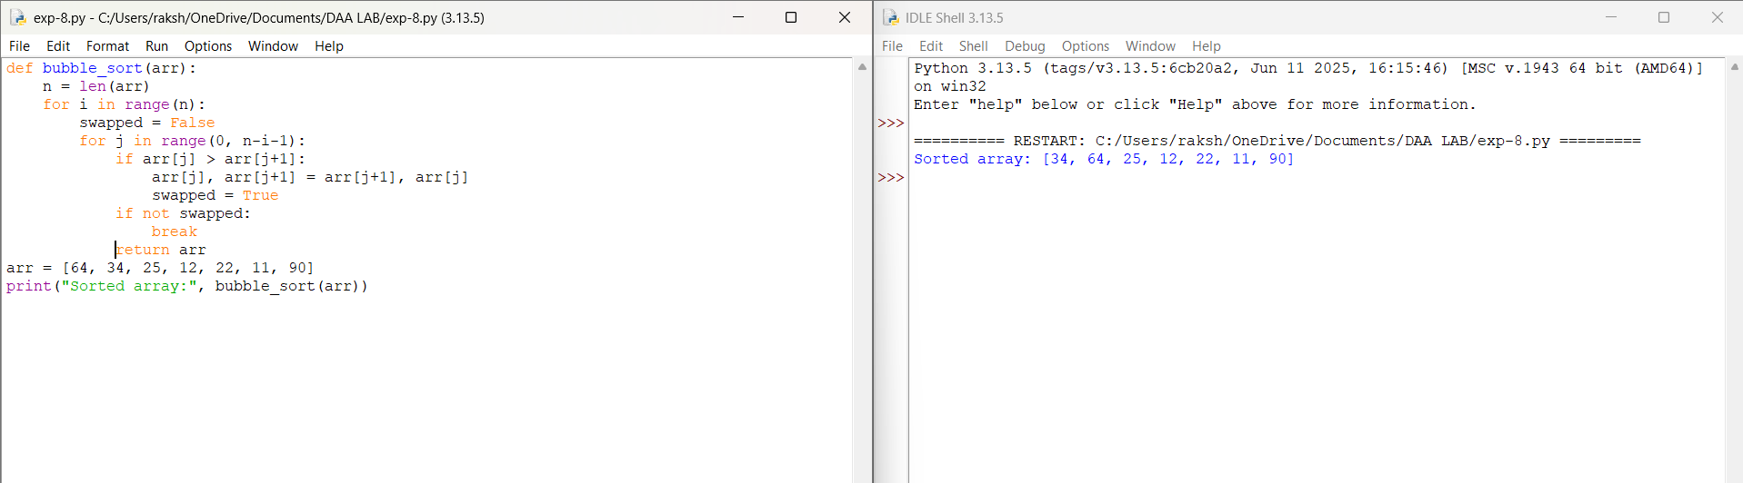

Time Complexity: O(n²)

Space Complexity: O(1)

Result: The array is sorted successfully using Bubble Sort.
Q9.Binary Search

Aim: Check if a given number exists in a sorted array using Binary Search.

Python Code:
def binary_search(arr, key):
arr.sort()
low, high = 0, len(arr)-1
while low <= high:
mid = (low + high) // 2
if arr[mid] == key:
return mid + 1
elif arr[mid] < key:
low = mid + 1
else:
high = mid - 1
return -1
arr = [3, 4, 6, -9, 10, 8, 9, 30]
key = 10
pos = binary_search(arr, key)
if pos != -1:
print(f"Element {key} is found at position {pos}")
else:
print(f"Element {key} is not found")

Input: Array = [3, 4, 6, -9, 10, 8, 9, 30], Key = 10

Output:
Element 10 is found at position 6
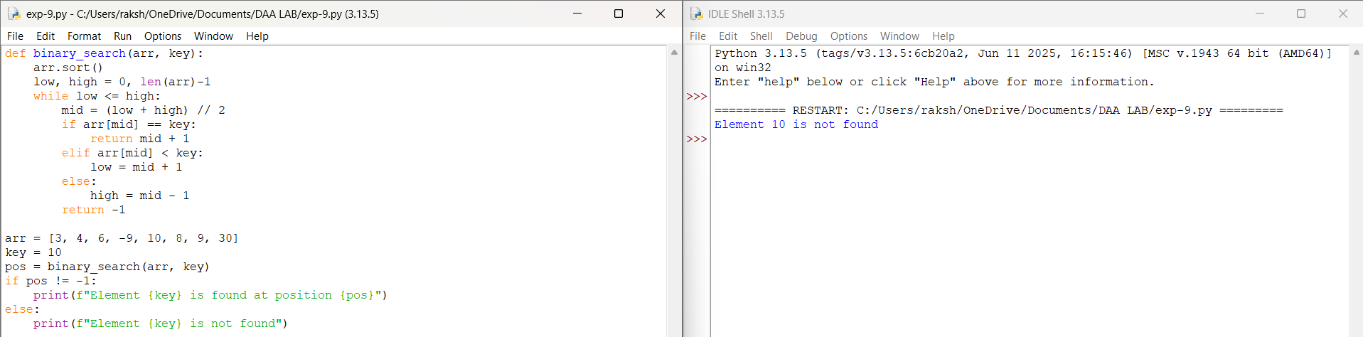

Time Complexity: O(n log n)

Space Complexity: O(1)
Result: The given element is successfully found using Binary Search.
Q10. Merge Sort (O(n log n) Sorting)

Aim:Sort an array of integers in ascending order using Merge Sort without built-in functions.
Code:
def merge_sort(arr):
if len(arr) <= 1:
return arr
mid = len(arr) // 2
left = merge_sort(arr[:mid])
right = merge_sort(arr[mid:])
return merge(left, right)
def merge(left, right):
result = []
i = 0
j = 0
while i < len(left) and j < len(right):
if left[i] < right[j]:
result.append(left[i])
i += 1
else:
result.append(right[j])
j += 1
result.extend(left[i:])
result.extend(right[j:])
return result
nums = [5, 2, 9, 1, 5, 6]
print("Sorted array:", merge_sort(nums))

Input:[5, 2, 9, 1, 5, 6]

Output:[1, 2, 5, 5, 6, 9]

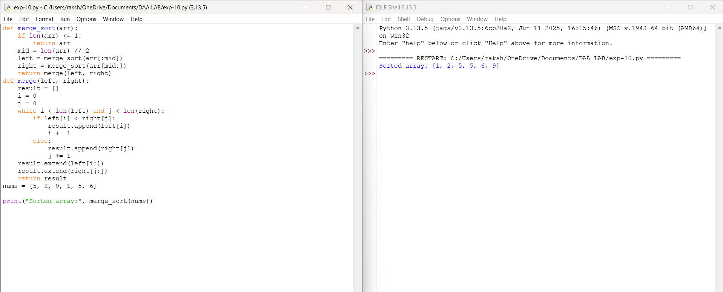

Time Complexity: O(n log n)

Space Complexity: O(n)

Result: The array is successfully sorted in ascending order using Merge Sort.

